28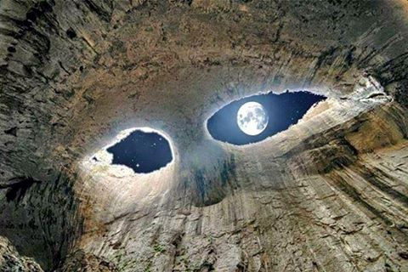
Curing the Gash

An Initiative led by Borderless World Foundation
www.borderlessworldfoundation.org

Review:
Conflict situations have never been new to Kashmiri people or Kashmir valley. From the past 28 years, Kashmir Valley has been witnessing a protracted conflict resulting in a huge impact on the day to day lives of common Kashmiri people. The last bout of serious violence in the region was in the summer of 2010, when more than 100 people died in anti-India protests, which broke out after police shot dead a teenager.
Born | Dadsara, Tral, Jammu and Kashmir, India
Died | 8 July 2016 (aged 21or 22)  Bumdoora, Kokernag, Jammu and Kashmir, India
Buried at | Tral, Jammu and Kashmir, India
Allegiance | Hizbul Mujhahideen (2011–2016)
Activity years | 2010-2016
Rank | Commander
Battles/wars | Kashmir Conflict
The conflict resistant Kashmir and its people once again witnessed the paradise on fire because of the killing of Burhan Wani- Commander Hizbul Mujahedeen. This 2016 unrest in Kashmir, also known as the Burhan aftermath, refers to a series of violent protests in the Muslim-majority Kashmir Valley in the Indian state of Jammu and Kashmir. It started with the killing of Burhan Wani, a militant commander of the Kashmir-based Hizbul Mujahedeen along with his two associates by Indian security forces on 8 July 2016 in the Kokernag area. Burhan was popular among Kashmiri’s due to his activities on social media because of which after his killing, anti- Indian protests started in all districts of the Kashmir valley.
Curfew was imposed all over the valley following the suspension of mobile and internet services by the government. To control the riots, the Jammu and Kashmir Police and Para-military forces used Pellet Guns, Tear gas shells, Rubber bullets and also live ammunition on the protesters, resulting in the deaths, injuries and disabilities.
Security forces while trying to control the Kashmiri agitators used Pellet guns, which although billed as "non-lethal", lead to a high number of casualties including permanent eye injuries. When pellet cartridges bursts, hundreds of tiny metallic particles jet out and penetrate skin and eyes, rupturing them before getting lodged.
Due to the medical emergency in Kashmir, there was a shortage of eye specialists who could treat the injured lying in Kashmiri hospitals. In Shri Maharaja Hari Singh (SMHS) Hospital of Srinagar, over 200 patients are presently admitted with the same problem.
In response State Government sends a three-member team of eye-specialists from the All India Institute of Medical Sciences from New Delhi to help the local doctors in treating the pellet gun injuries. After watching the condition of patients in the hospital, they described the situation as a "war-like situation".
By 22 July, the SMHS Hospital has received at least 182 patients with eye injuries caused mostly due to pellets with more than 137 eye surgeries having taken place (DR. Tariq Qureshi, HOD ophthalmology dept. - SMHS)
The local newspaper of Valley - Greater Kashmir on 8th August, 2016 published, crises undertook in one month;
July 8th | HM Commander Burhan Wani dies in kokernag; protest, clashes begin
July 9th | 12 protesters shot dead, 200 injured.
July 10th | 4 more civilians cop killed; 5 succumb to injuries.
July 11th | 9 injured succumb
July 12th | 1 more civilian dies; 1 injured succumbs
July 13th | 3 injured succumb; 1 fresh killing
July 14th | Kulgam teenager dies; toll mounts to 38
July 15th | 2 more youth killed
July 17th | Printing presses of newspapers raided, no newspapers for next 5 days
July 19th | Court directs police to register FIR against Dy SP Yasir Qadri for allegedly killing Tengpora youth Shabir Ah.
July 22nd | 1 injured succumbs, 1 new killing; death toll reaches to 47( 5 people were killed during ban on press)
July 23rd | Home Minister arrives on 2 day visit to Kashmir, asks forces to avoid use of pellet guns.
July 24th | 2 civilians and a cop succumb; death toll touches 50
July 29th | Another Civilian succumbs.
August 2nd | A civilian killed when guards of ADC Ramban open fire on protestors in Lethpora.
August 5th | 3 youth killed in forces firing. Death toll 56 (400 people got injured on this day).
493- Bullet injuries.
410- Eye Pellet injuries.
27- Head and spine injuries due to Bullets, pellets and shells.
1558- Surgeries both major and minor conducted.
1600- Person’s treated in Srinagar Hospitals.
3400- Persons treated in District Hospitals.
800- Persons treated in Anantnag, Kulgam, Pulwama, Shopian and Kupwara district hospitals. ( till one month)

On 22nd November 2016, Kashmir is observing the strike on the call of separatists for 136th day. As many as 96 civilians and 2 police personnel have been killed and several thousand civilians injured in the ongoing uprising (2016, November 23rd). E-Paper Greater Kashmir. Retrieved from epaper.greaterkashmir.com.

Brief about Borderless World Foundation (BWF):
WHO WE ARE:
Borderless World Foundation (BWF): is a Non-Governmental, Non-Profit Organization, established on 8th March 2002 and registered under the Societies Registration Act, 1860, Bombay Public Trust Act, 1950(BPT) with its registered office at Block F, Nikhil Pride_ Phase II, Tilak Road, Sadashiv Peth, Pune_411030 in the state of Maharashtra, Registered under Foreign Contribution Regulation Act (FCRA) and section 80G of the Income Tax Act. BWF is also registered as a Charitable Trust in the State of Jammu & Kashmir with Trust Registration No. 57, with its registered office at 3rd Floor Dar Building, Opposite Florence Hospital Chanapora, Srinagar _ 190015. BWF is working since late 1990s for rehabilitation and socio-economic empowerment of the poor and deprived sections of the society in the strife-torn valley of Kashmir. With strong belief in the values of compassion and inherent dignity of human beings, the organization strives for ‘one great human family’ by working for the well-being of the affected, and the displaced population, irrespective of race, religion, and political persuasion. BWF launched its rehabilitation projects as Foster care Homes for Orphan and vulnerable girls in the frontier district of Kupwara, Beerwah_Budgam, Anantnag and Jammu, with the hope of making a positive difference to more lives. BWF is mostly working with girl children, empowering people is at the core of its activities.

- Rehabilitation of children (esp. orphans)
- Education
- Health care support
- Rural development by providing livelihood support.

Previous Work in J&K Crises
Our Mission:
- To develop socio-cultural proximity and enrich the local social structure.
- To work towards physical and psychological recovery and social re-integration of conflict affected children and women
- To assist in Education, Health-Care, Rural Industrial and Economical development in conflict hit areas.
Our Vision:
“Empowerment of conflict affected children to reach their full potential through education and socio-economic initiatives”
Our Values:
These traits express the belief and define the culture of the organization. We remain guided by the timeless values and teachings provided by the revelations contained within the holy books.
- Our actions in tackling problems are marked by excellence in our operations and conduct, which are deserving of the children we serve.
- In responding to the sufferings and problems, our efforts are driven by sincerity to God and the need to fulfill our obligations to humanity.
- We believe the protection and well being of every life is of paramount importance and we shall join with other humanitarians to act as one in responding to the sufferings brought on by disasters, conflict, poverty or injustice.
- We uphold our duty of custodianship over the trust people place in us as humanitarian and development practitioners. We are transparent and accountable.

September 2014 Floods; Disaster Relief: The state of Jammu and Kashmir got terribly affected by the devastating floods of September 2014 resulting in loss of human lives and property. In the wake of that tragedy, Borderless World Foundation without wasting any time rushed to provide medical relief services to the flood victims of the valley.
- Accordingly, 127 doctors from Pune, Maharshtra along with 10 ambulances were brought for free medical assistance in 7 districts of the valley. 4.15 cr cost medicines were raised as in kind donation from many corporate hospitals and local contacts of BWF in Pune. 3.87 lacs patients were assisted by the doctors and around 8 lacs rupees were spent by Borderless World Foundation on managing the above given service.
- Moreover, 5lacs rupees were spent on providing stationary items and reestablishing looms for some severely affected families in District Baramulla.
- In addition 3600 blankets and 400 solar lamps were distributed among the effected households across the valley
- Four fully equipped Cardiac and trauma care ambulances as “Kashmir Lifeline” was donated by Borderless World Foundation to State Government on 21st of September, 2015. The ambulances were launched by Late Chief Minister, Mr. Mufti Mohd. Syed from his residence.

Response of Borderless World Foundation towards 2016 unrest
Seeing the valley on once again facing severe crises, mourning the deaths of their beloved ones, Borderless World Foundation once again send out its local team headed by Sheikh Shahnawaz Zahoor, Chairman, BWF -JKL to access the reality of ground and realize the need of the hour. Mr. Zahoor formed a team of 4 Officials of BWF for field study.
Mr. Haris Abrar Kashmiri- Sr. Program officer BWF
Ms. Iqra Javed- Program Officer BWF
Ms. Gitanjali Das Gupta- Internee BWF from Pune
Mr. Khurshid Bhat- Volunteer BWF
Before going on field a plan of strategy was formed as
- Observation/listening
- Basic data collection – Qualitative
- Assessment of immediate need
- Plan of intervention
- Implementation
- Follow up

Field Experience:
On day first, as a team when everyone met after a long break it was somehow psychological first aid for each member as everyone was locked in homes due to curfew and nobody was having an access to mobile services and internet. There were some ideas on everyone’s mind gained through news channels that pellet injuries have increased, situation at hospitals are grim, patients facing insufficient medical assistance etc but the real scenario was felt by everyone after entering the SMHS Hospital. The scene was community kitchen (voluntary organization’s preparing food for patients) going on, panic, chaos, frustrated masses, depressed faces, cries, screams, sirens of ambulances were seen and heard all around.
As decided the team went into the wards of Eye pellet injuries, observing the situation.
Due to continuous increase in number of patients, two patients were placed on one bed. The attendees with the patients were crying in search of hope for their wards as they were complaining that no one is telling them the reality what has happened to their wards and is there any chance of Vision restoration.
The team decided to talk with some attendants and patients for more clarifications. We in team went to one patient and started giving introduction of the team and the overall motive behind the visit.
While doing so, we were surrounded with people and all of them were looking at us with suspicious eyes as they were informed that some agents from police are roaming. Meanwhile one small child of 15 or 16 year old cried out thought that we might be from media.
“You press people come here to listen to our woes but don’t report it. Please don’t do this, Kashmir is burning,”
Trying to build some rapo, the team started to answer the enquiries. It was felt that no one was giving us the correct information and majority of them was not interested to talk. The hopelessness and fear was visible on everyone’s face.
“Doctors came, put eye drops on our eyes and left, what has happened to us no one is answering” said Amir (name changed) a 17 year old boy.
Everyone was enquiring about the vision restoration whether that was patient or attendant. The people over there were frustrated and depressed so, respecting the individuality and willingness of people over there, the team left to meet Dr. Tariq Qureshi, H.O.D Ophthalmology Department- SMHS
Dr. Tariq showed great response and support towards the meeting. The following information was revealed
- We saw in wards that the patients have operated once but they are not discharged yet?
The patients have operated once and the reason behind keeping them in hospital is that the pellet is still in their eye and doctors are not able to operate that due to non availability of Retina surgeon.
The patients who were having pellet in other sections of eye have been treated and discharged but the patients who are presently in wards are the one who have pellets in their Retina.
- At present how many patients are such?
Presently, there are around 105 pellets injured in hospital out of which 70 are those who have retina injuries and needs to be treated immediately. On personal level we are trying to coordinate with outside hospitals for their surgeries but the number is very high and day by day it’s increasing.
- What SMHS needs most at present which can help?
Presently we are facing non availability of some medicines, the list of the same can be provided to you and equipment called as Portable B-Scan is required which is used in surgeries.
The team of BWF thanked Dr. Qureshi for spending some time from his busy schedule and requested for one more meeting for discussing the possible way of intervention by BWF. The list of medicines was taken along and the report of the same was discussed with Mr. Zahoor- Chairman BWFJKL and head office Pune.
Through the meeting with Dr. Tariq Qureshi it was accessed that the immediate need of the hour was to cure the retina damages of pellet victims as some local NGOs and Voluntary groups were already working on the procurement of basic requirements like food and medicines.
The board members of BWF first decided of getting the patients flown out of Kashmir for better treatment but encountered logistical problems and the process seemed time consuming as it was not the matter of one surgery, there were plight of pellet victims which were in need of immediate help. After lot of overnight discussions and meetings, the plan of intervention was formed and it was decided to bring surgeon doctors to valley for conducting Retina surgeries.
But things don’t always turn up easy for NGOs. In all this action the support and trust of SMHS doctors and patients was required for which on 11th July, a meeting was held between Suhail Masoodi (Advisory BWF), Dr. Arshad, Dr. Sajad Khandey, Dr. Saleem -ur- Rehman along with some more dignitaries of health department. The meeting ends up on suggesting that only best services can heal the patients. The need of hour and minutes of meeting was shared by Suhail Masoodi with the board members of BWF- Pune comprising of Sheikh Shanawaz Zahoor- Chairman BWFJKL, the Founder of BWF- Mr. Adhik Kadam, Mr. Aslam and Dr. Rushikesh.
Not wasting much time Dr. Rushikesh, who acted as a coordinator for this program met Dr. S. Natrajan as he can be the only choice when thought of Retina surgeon comes in anyone’s mind. Dr. Natrajan was briefed about the situation of ground zero and the nature of the injuries. In response without any hesitation he agreed upon operating pellet victims and started coordinating with Dr. Rushikesh for the same cause.
Dr. Tariq Qureshi showed an immense support and welcomed our proposal of help and started coordinating for the same with Mr. Adhik Kadam, Founder-BWFJKL and Mr. Suhail Masoodi, Advisory-BWF in order to maintain the confidentiality of records of patients.

Arrival of Doctors
With lot of hard work and support from SMHS hospital especially Dr. Arshad, Dr. Sajad Khandey, Dr. Saleem-ur-rehman and Dr. Tariq Qureshi Borderless World Foundation was able to facilitate free Retinal Surgeries at SMHS Hospital, Srinagar.
A team of three eye-specialists arrived on 26 July all over from Mumbai to treat eye injuries caused by the pellets. The team was led by no doubt Padma Shri awarded, Madurai-born ophthalmologist, who is chairman-cum-managing director of Aditya Jyoti Eye Hospital, Mumbai, Internationally acclaimed vitreous retina specialist and renowned ophthalmologist Dr. Sundaram Natarajan along with his team of two retina surgeons Dr. Syed Asghar Hussain from Chennai and Dr. Kenshuk Marwah from New Delhi.
The doctors were welcomed by Personal Assistant of Dr. Tariq Qureshi and BWF members. The doctors were accompanied with Dr. Rushikesh who is associated with BWF since its inception. After landing on Srinagar airport, without wasting any time all the doctors went to SMHS, meet patients in wards and start operating them.
As the news spread in the wards of SMHS that Dr. Natarajan along with a team of doctors has came to treat pellet victims, everyone was boosted with a ray of hope and the news imposed life to their dead emotions and trust for the doctors and BWF team was seen in everyone’s face and gestures. The response and trust of patients and attendees pumped the positive motivation in the atmosphere. The place which was shattered with hopelessness and anger was suddenly full of hopes and satisfaction and the arrival of doctors turned to be a healing touch.
With a deep breath, an attendant with one of the patient came to us and said,
“We are sorry as we thought you are here to make only story on us but you have come up with such a great help, May God bless you”.
The team of doctors was joined by one more doctor as Dr. Gaurav Paranjype on 28th July, a retina surgeon from New Delhi. Three members of the team, including Dr Natarajan, left Srinagar on 29th July, the team more than 40 surgeries at the SMHS hospital till 29th July afternoon. The lead Dr. S. Natrajan operated on 40 patients himself. On 29th July evening Dr. Ashish Holani from Ahmadabad reached Srinagar and joined Dr. Gaurav to carry out further surgeries.
After Surgery one patient Huzaif (name changed) said,
“I am feeling relieved as I heard while doctor was operating me that the pellet in the eye is taken out, you are ok”.
Two remaining doctors as Dr. Gaurav and Dr. Ashish left valley on 31st of July and conducted 15 surgeries at SMHS.
Adding as fuel to fire, the number of pellet victims doesn’t seem to decrease for which BWF brought one more Retina Surgeon Dr. Mahesh P. Shanmugam on 6th August who operating the pellet victims at SMHS hospital. The doctor left the valley on 9th August and conducted 25 surgeries.
In total …. surgeries were conducted by all the doctors and this would not have been possible without the great help and support of Dr. Tariq Qureshi and his dedicated team of doctors and staff who done a commendable job. Dr. Tariq Qureshi had been instrumental in the implementation of this program on ground and kept operation theatres available 24x7.
BWF is grateful to Dr. S. Natarajan and his team who continuously performed surgeries and proved a godsend to the shortage of eye specialists who could treat the injured lying in Kashmiri hospitals; otherwise it would not have been promising to achieve huge number of surgeries in small span of time. BWF thanks its inmate Dr. Rushikesh who has always been an active support for BWF. BWF is grateful to all other doctors who came up for this noble cause without giving a second thought and helped Borderless World Foundation to make the initiation of this program happen towards the valley during the ongoing crises.
Borderless World Foundation has always tried to minimize and be a boon to the sufferings of people without any discrimination. Being a non political and non-governmental organization BWF has always tried to help the valley in the time of crises as we believe only unity can heal the wounds.

We (BWF team) appreciate your efforts for being united, kind and supportive throughout the process and thank you from the bottom of our hearts as we believe,
“Alone we can do so little, together we can do so much.” (Hellen Keller)

Date | Team of Doctors | Number of surgeries conducted
26th July -29th July | Dr. S. Natarajan along with his team Dr. Syed Asghar Hussain and Dr. Kenshuk Marwah | 40
29th July -31st July | Dr. Gaurav Paranjype and Dr. Ashish Holani | 6
….Aug- …Aug | Dr. Mahesh P. Shanmugam | 25
Total Number of Surgeries undertaken individually
Dr. S. Natarajan |  | 40
Dr. Syed Asghar Hussain |  | 03
Dr. Kenshuk Marwah |  | 03
Dr. Gaurav Paranjype
Dr. Ashish Holani

Dr. Mahesh P. Shanmugam |  | 25
Total Number of Surgeries Conducted at SMHS Hospital

Profiles of Doctors:

Follow up:
According to Dr. S. Natarajan the recovery of eye sight would depend on the extent of the injury and follow up treatment and the position of the recovery of eye sight can be said only after six weeks to six months. BWF thought immense need of follow up and requested Dr. S. Natarajan for conducting few follow ups as the patients have varied defects caused by pellets, which include retina, vitreous injuries, cordial detachment and traumatic cataract and of now nothing about recovery of eye sight can be said. In response without any hesitation, Dr. S. Natarajan named the project as “splinted Kashmir” and has assured that he will be coming to the valley once in every month for follow ups treatments of pellet victims just to have effective results and will held 1st follow up on 22nd of August 2016 at SMHS Hospital.
Dr. Natrajan who is famous nowadays by Pellet Raja or Pellet Rajan in local youth, had his 2nd visit to valley on 22nd of August as promised and was expecting to conduct 60 new retinal surgeries and checkups of all operated before, during his stay till August 25th. The SMHS hospital had so far admitted more than 100 patients with pellet injuries in their eyes and Dr. Natrajan with follow up checkups simultaneously conducted ……. surgeries of newly injured pellet victims and revealed his plan to visit Srinagar on next month.
Follow up treatments of pellet victims
Date and month | Follow up by | Number of surgeries conducted of newly admitted pellet injured
22nd Aug – 25th Aug | Dr. S Natrajan
20th Sept ----- | Dr. S Natrajan

Borderless World Foundation was only a way; the creator of the event was lord himself so, we can only pray for vision restoration of all patients and hope that this initiative bore out some good results, rest depends on God. After all, universe relies on hope.
God bless Kashmir with peace and prosperity.

News Links:
http://cnskashmir.com/pellet-guns-causing-genocide-in-kashmir/
http://kashmirreader.com/2016/07/30/disastrous-situation-in-kashmir-says-indias-leading-retina-surgeon/
http://epaper.kashmirmonitor.in/newsarticle.aspx?Mode=1&parentid=38456617&boxid=459139
https://kashmirobserver.net/2016/city-news/mehbooba-interacts-ophthalmic-surgeons-8961
http://www.dailyexcelsior.com/mumbai-doctors-perform-46-eye-surgeries-in-3-days-in-kashmir/
http://www.knskashmir.com/news.aspx?news=Eye-injuries-by-pellets-are-severe-here-than-in-other-conflict-hit-regions--Dr-Natarajan-9680
http://www.dailyexcelsior.com/cm-interacts-with-ophthalmic-surgeons-seeks-update-on-condition-of-injured/
http://www.knskashmir.com/news.aspx?news=CM-interacts-with-ophthalmic-surgeons--seeks-update-on-condition-of-injured-9682
http://twocircles.net/2016jul28/1469717311.html#.V5wB51G6bqB
http://jknewsservice.com/disastrous-situation-in-kashmir-says-indias-leading-retina-surgeon/
http://www.risingkashmir.com/news/large-scale-eye-injuries-by-pellets-is-disaster-dr-natarajan
http://www.knskashmir.com/archives/news.aspx?news=Expert-doctors-from-Mumbai-conduct-surgeries-on-pellet-injured-at-SMHS-9595
http://www.kashmirlife.net/day20-attention-pellet-victims-call-borderless-world-foundation-for-treatment-112632/
http://jknewsservice.com/bwf-conducts-retinal-surgeries-at-smhs-hospital/
http://m.greaterkashmir.com/news/kashmir/outside-doctors-conduct-24-major-retinal-surgeries-at-smhs/224141.html
http://www.risingkashmir.com/news/bwf-conducts-retinal-surgeries-at-smhs-hospital
http://m.greaterkashmir.com/news/life-style/story/224171.html?fromNewsdog=1
http://twocircles.net/2016jul28/1469717311.html#.V5q5nfK6bqB
http://m.ibtimes.co.in/24-surgeries-24-hours-mumbai-ophthalmologist-infuses-hopes-kashmirs-pellet-victims-688170
http://www.tribuneindia.com/mobi/news/jammu-kashmir/chennai-surgeon-comes-to-aid-of-pellet-victims/272662.html
http://www.deccanchronicle.com/nation/current-affairs/280716/humanity-sans-borders-mumbai-surgeons-treat-kashmirs-pellet-gun-victims.html
http://www.kashmirlife.net/day20-attention-pellet-victims-call-borderless-world-foundation-for-treatment-112632/

Gallery:
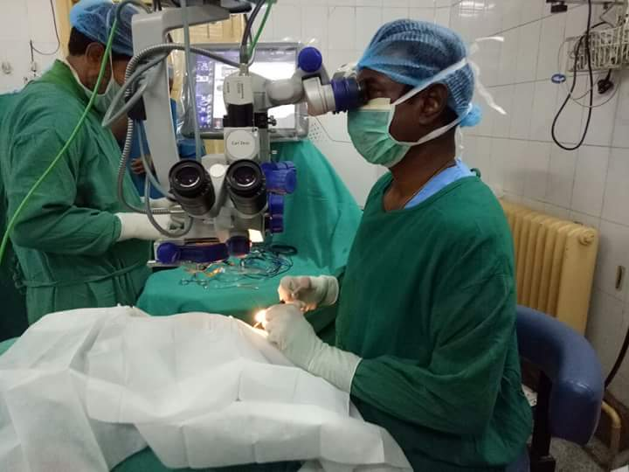
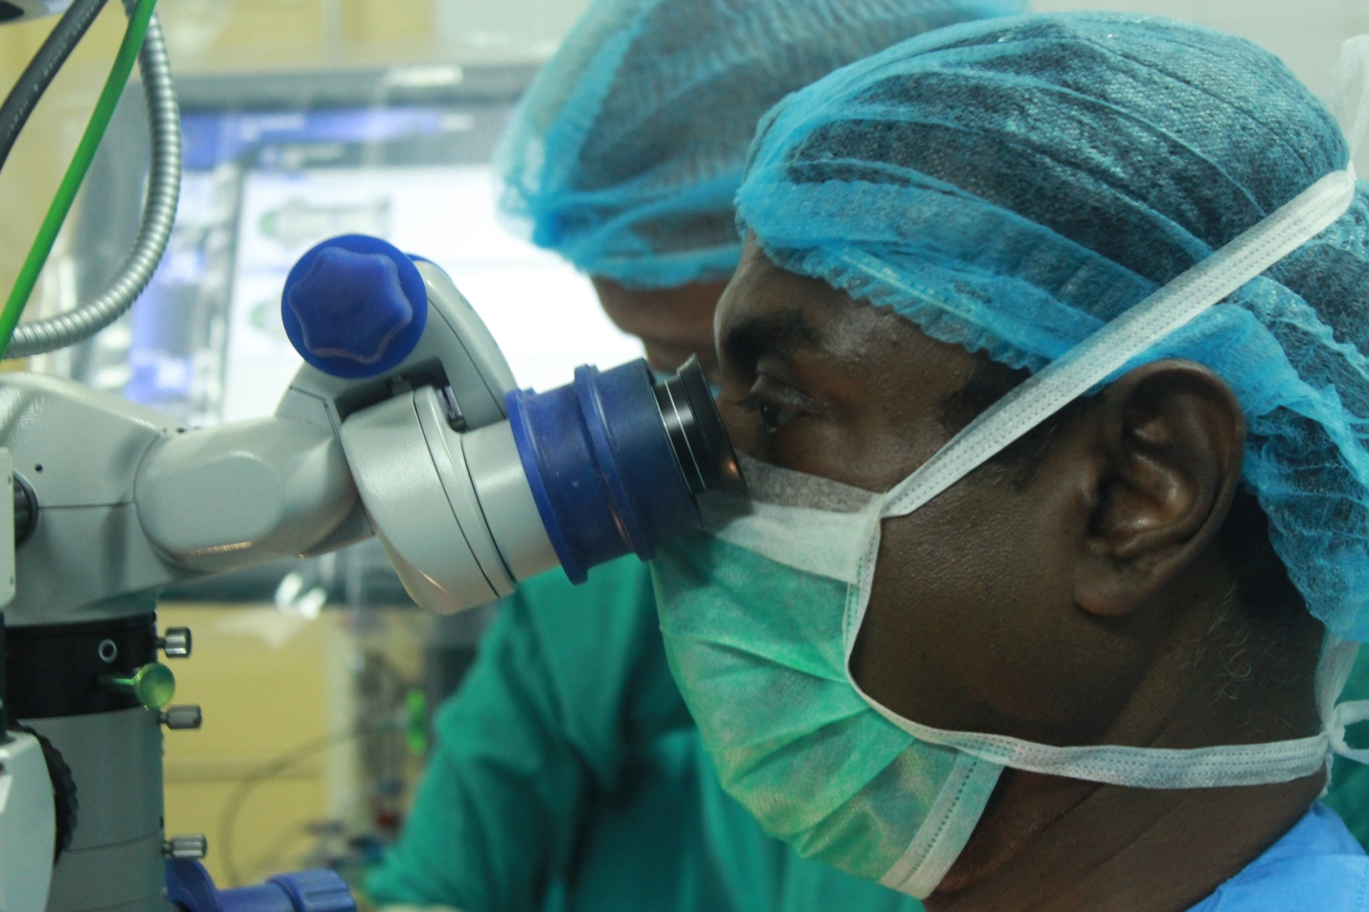

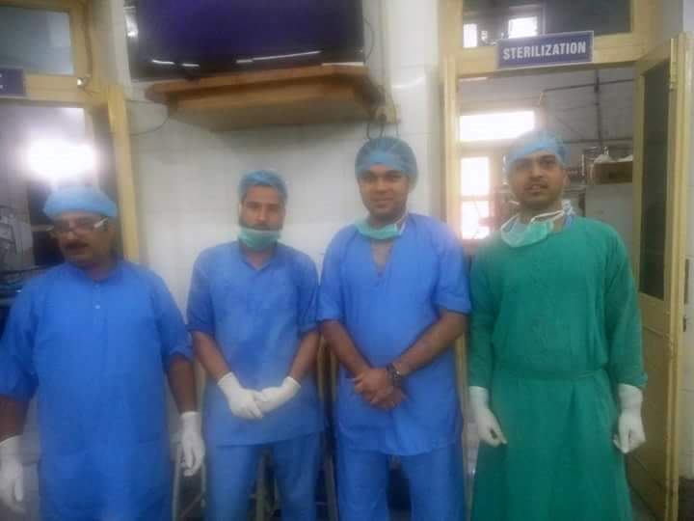
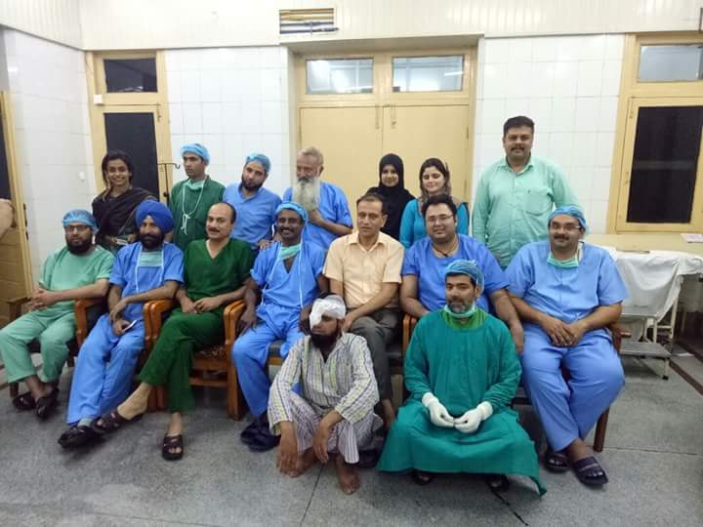
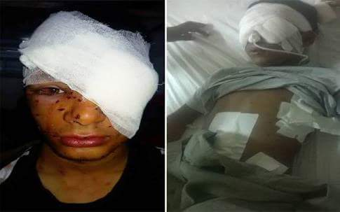
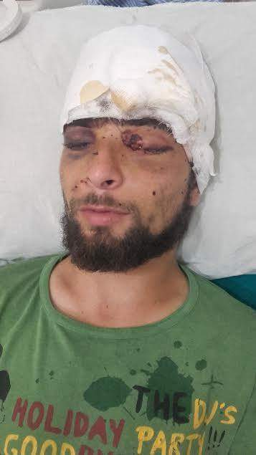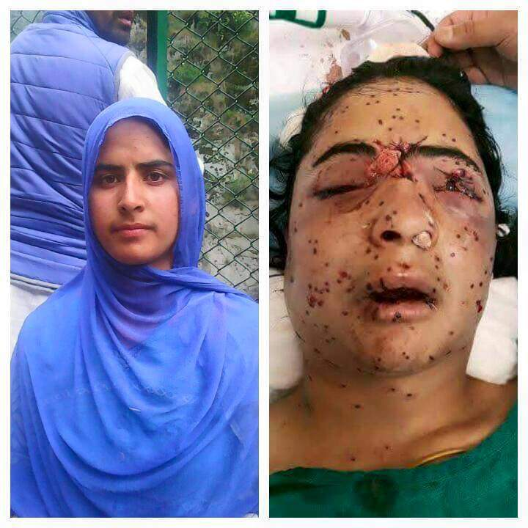
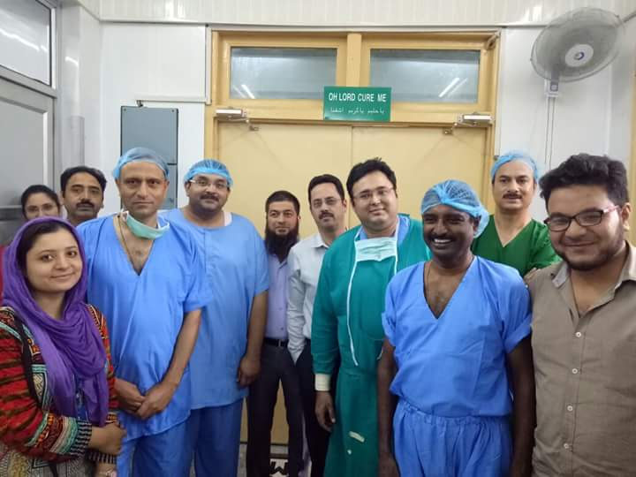

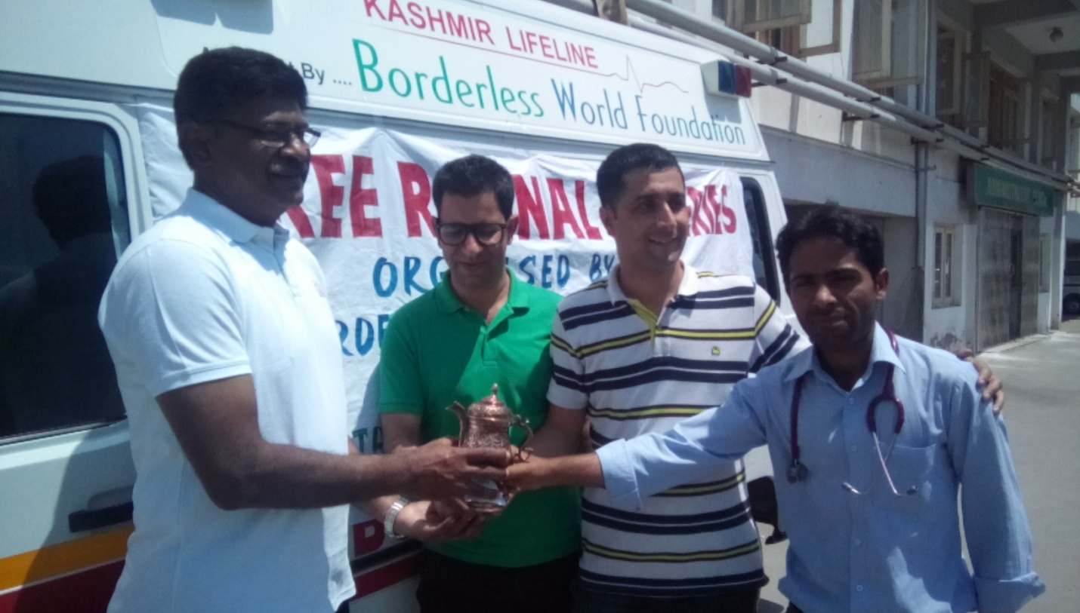
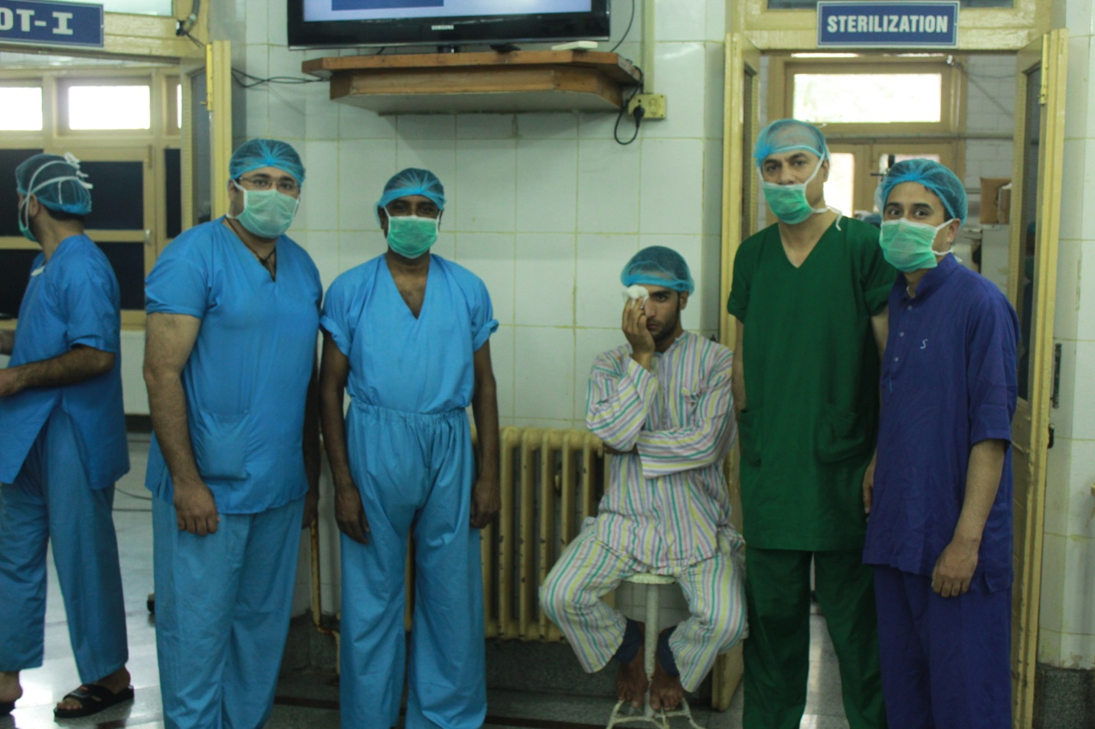
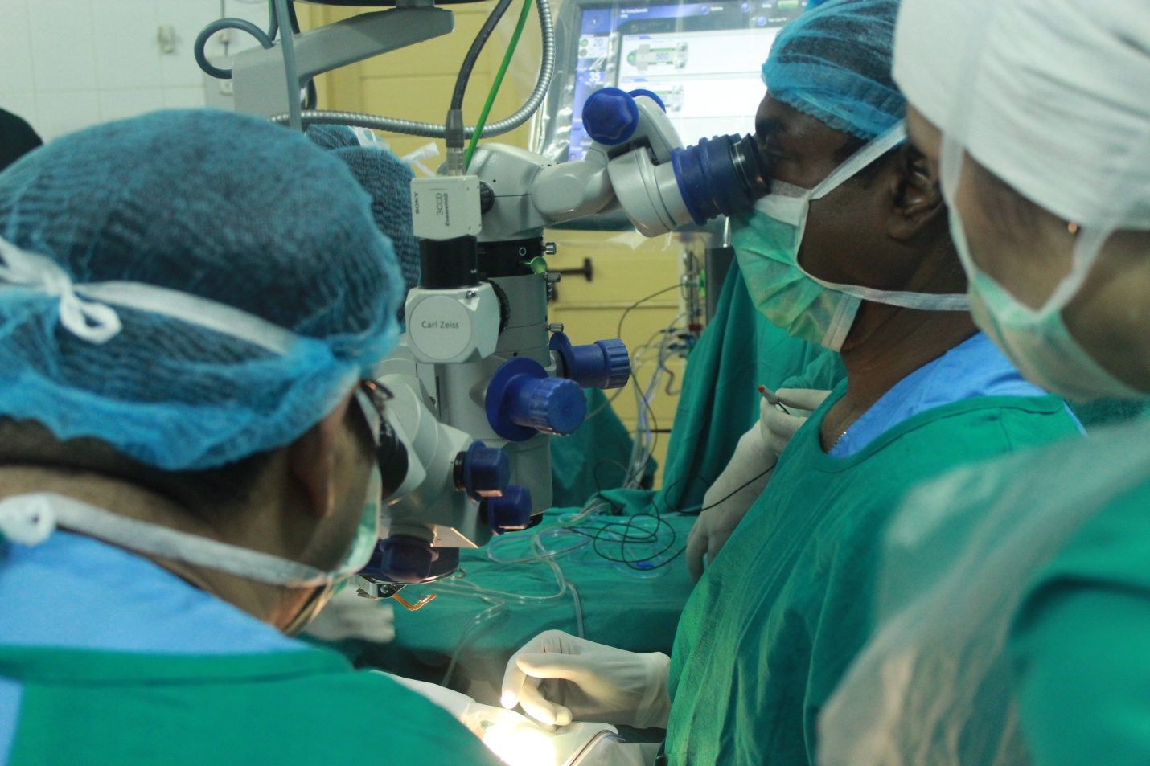
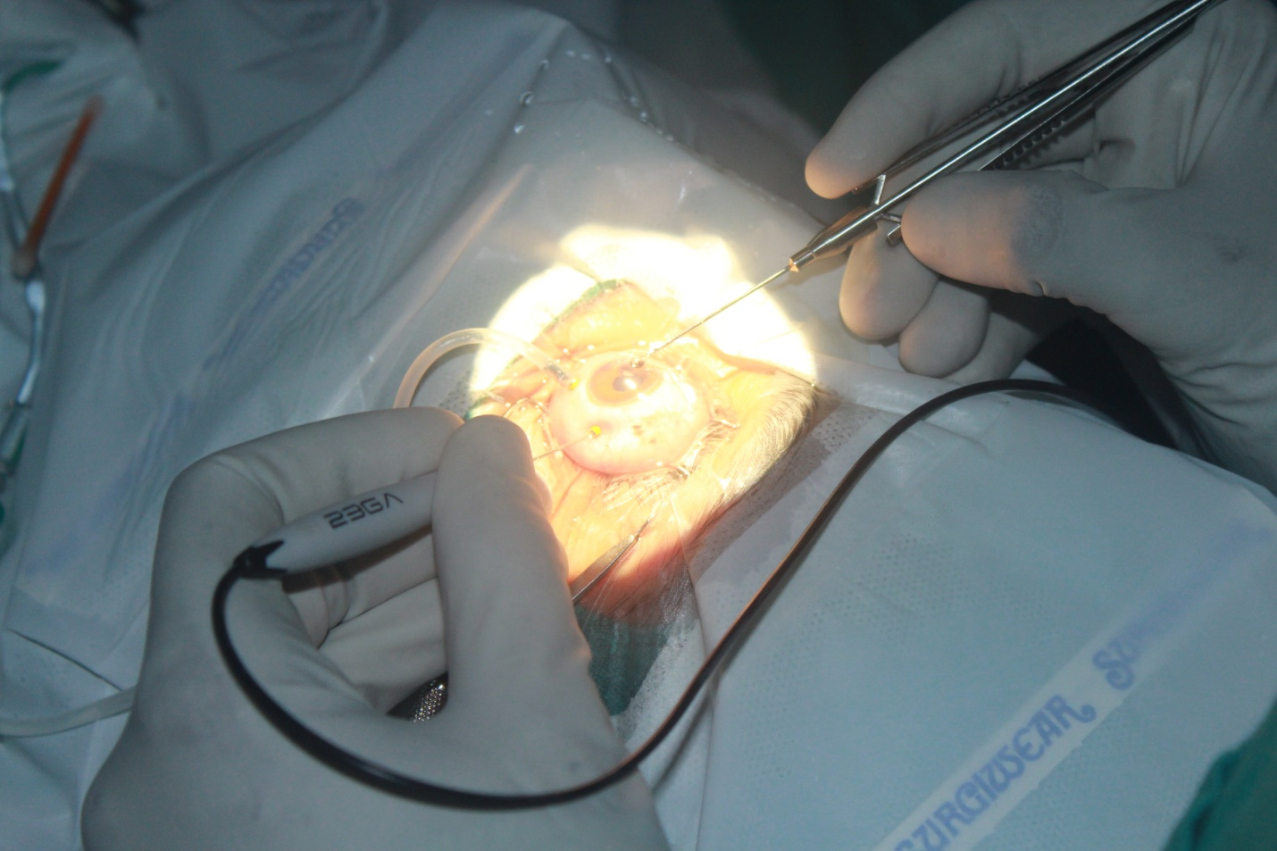
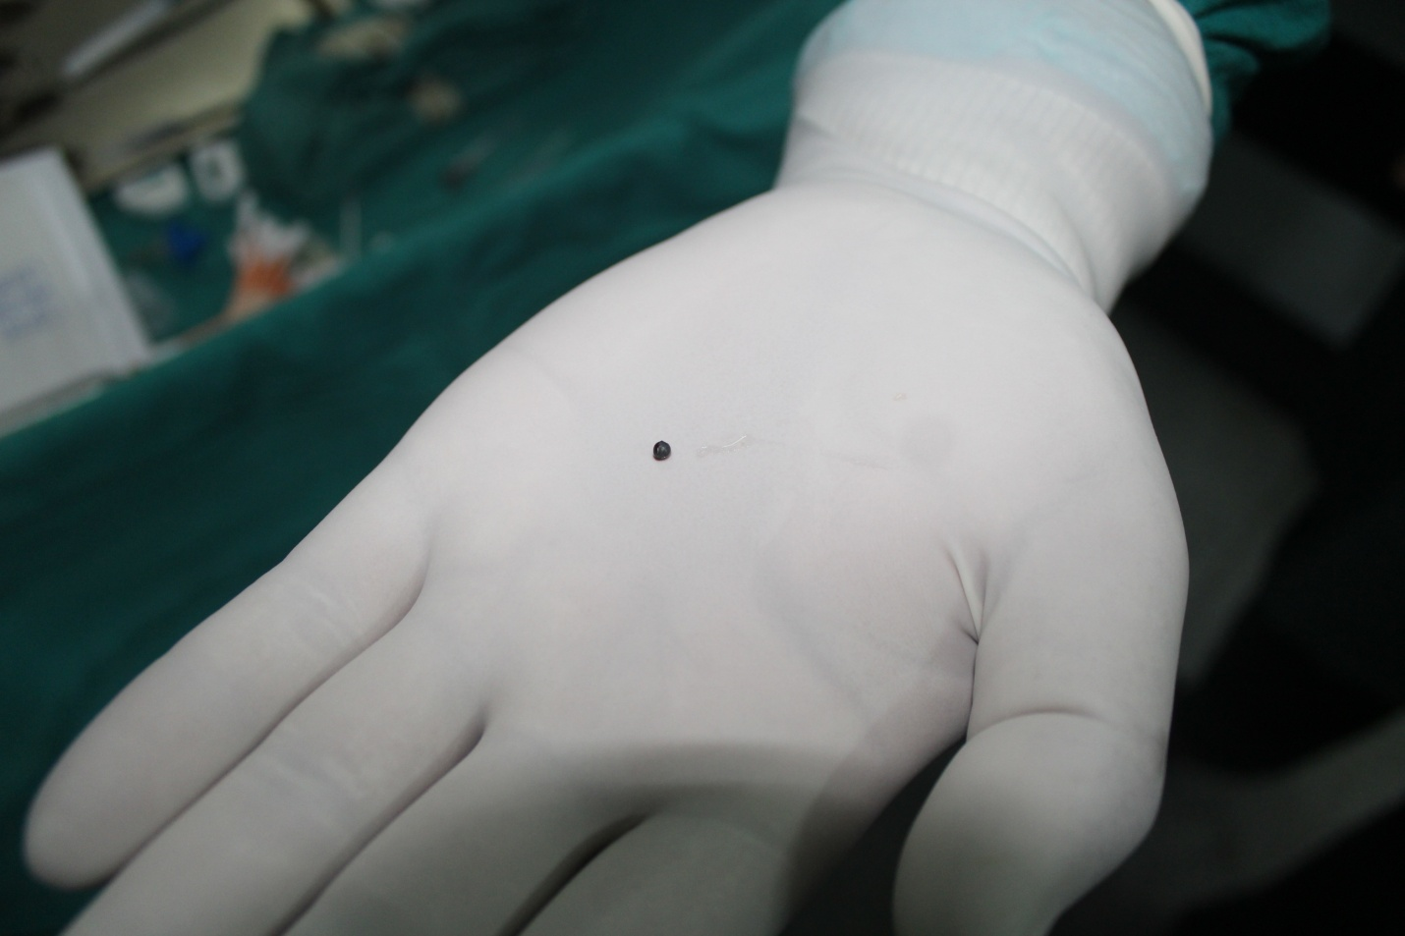
During Follow ups
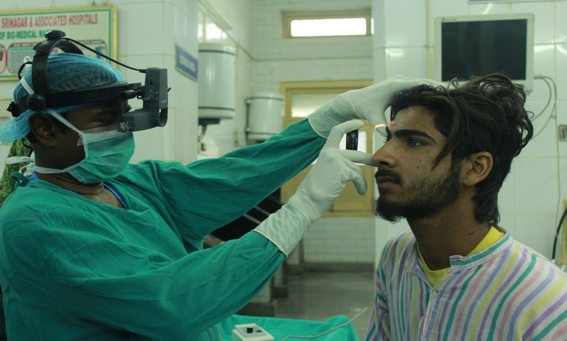
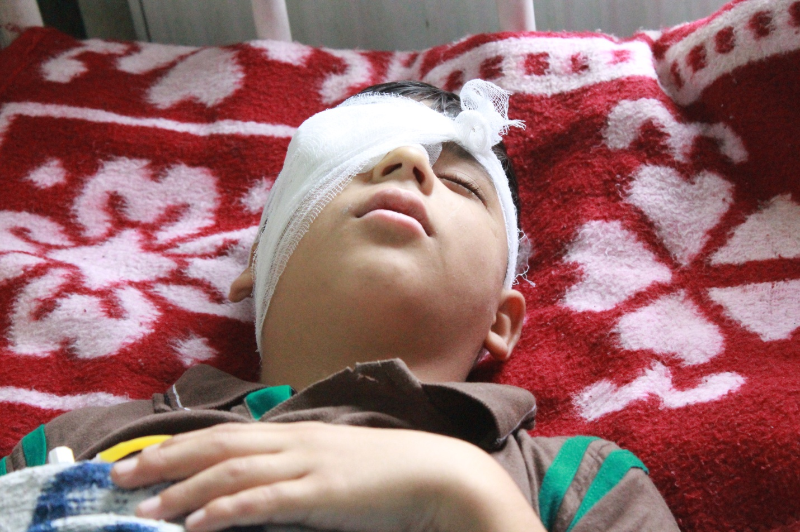
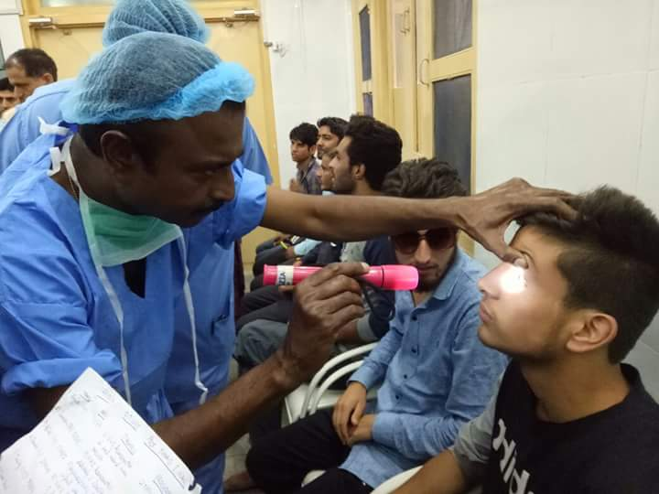

Report by
Iqra Javed
Programs Officer- BWF

